SkillsUSA 2024 Additive Manufacturing State Challenge

Medallion Models

Welcome to the “logo Medallion” challenge!

The task at hand is to design an eye-catching medallion that represents your school, yourself, mascot, state, country, event, or hobby.

Design Examples:
- Bump Maps
- Displacement Texture
- Color/Material Changes
- Embossed/Debossed Text
- Motion

Example of a Basic Design
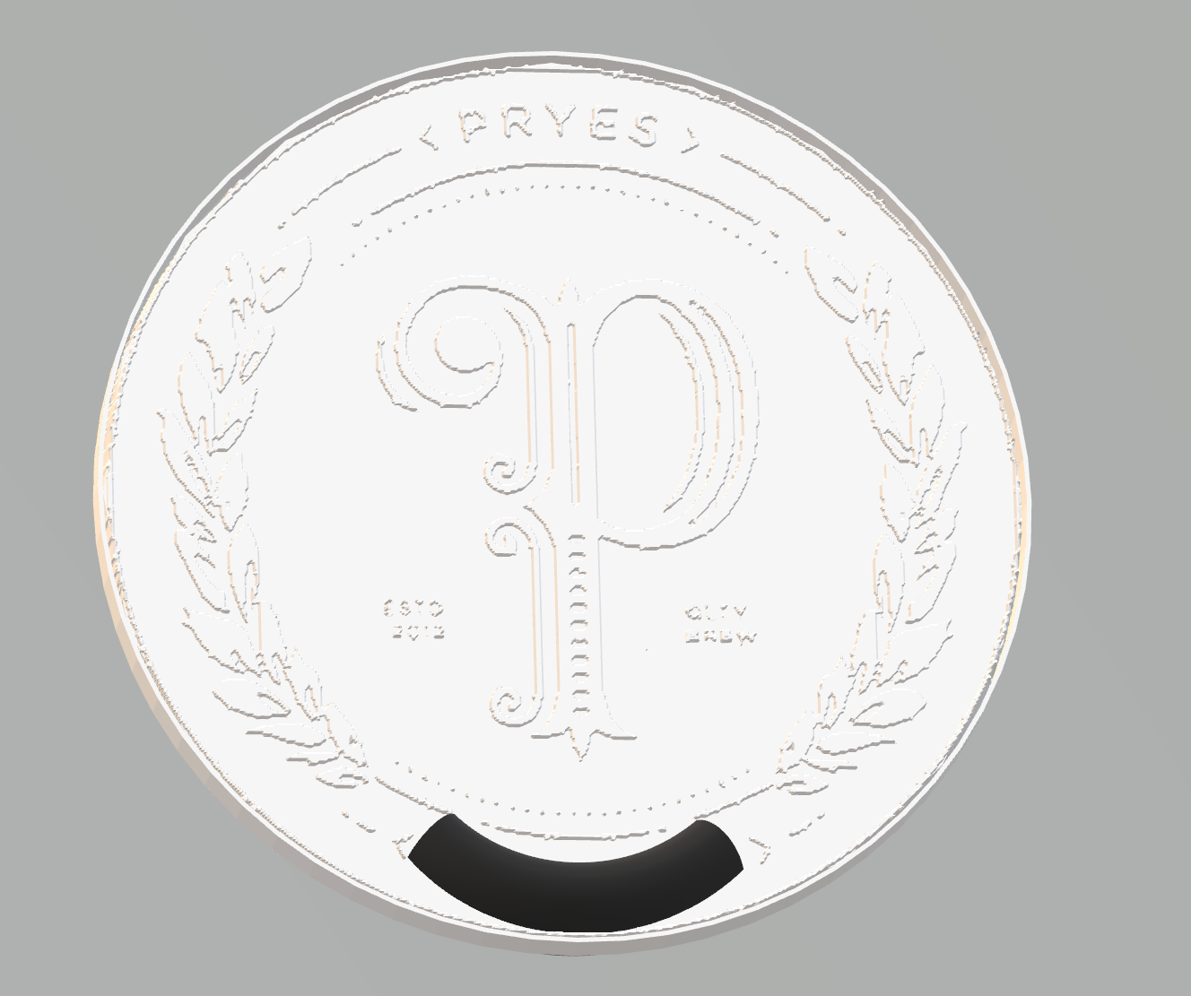

Competition Requirements

- The design must be completely 3D printed.
- The design can be 3D printed using any technology.
- The design must contain at least two legibly printed words.
- The design can contain 3D printed bodies that are glued together for the final part.
- Parts can be colored or painted.
- The printed design can have moving bodies.
- The design must be at least 3” x 3” x ¼”
- 3D Printed Design - Students must create a design that:
  - Is original and designed by competitor
  - Prints all parts in less than 8 hours
  - Uses less than 5 cubic inches of model and/or support combined for all parts.
- Students must submit CAD files (.step, .iges, .sldprt, etc.), and Mesh files (STL, 3MF, OBJ, etc.), as well as screenshots of the print time and material usage for all printed parts, to apanek@depcollc.com and/or support@depcollc.com no later than 5:00 PM on March 29th, 2024. Final printed parts/assemblies will be completed by participants ahead of time and submitted on the day of the contest for evaluation.

Tips for Competitors
Here are some tips to maximize the points awarded to you:
- Build debossed text on a horizontal surface for best results. This may require building the part on its edge or standing up.
- Paint 3D is a free tool to help design the part.
- Try to leverage a design with multiple printed colors or technologies for a more creative part.
- Leverage post-processing techniques to smooth or color printed bodies.
- Additional moving parts may add to your score but can produce more points of failure on the final assembly.
- Use online resources (YouTube, GrabCAD Tutorials)
- Whenever intellectual property (IP) deters you from a project, try using approximate geometries to communicate the design intent.
- Optional design for additive manufacturing learning resources:
- Stratasys Think Additively™ Masterclass:
  - https://youtube.com/playlist?list=PLUYaY5EIPtNBdU-s-7l9rl05lBHHlTarI

State Competition Procedure
Before competition day:
  - Submit print files in CAD (.step, .iges, .sldprt, etc.), mesh (STL, 3MF, OBJ, etc.) formats, as well as screenshots of the print time and material usage for all printed parts
- . Send to: apanek@depcollc.com and/or support@depcollc.com no later than 5:00 PM on March 29th, 2024.

On competition day:
- Students submit Engineering Notebook (See engineering notebook guidelines below.)
- Students previously submitted print files in both CAD (.step, .iges, .sldprt, etc.) and mesh (STL, 3MF, OBJ, etc.) format will be reviewed.
- Students submit physical parts. Final printed parts/assemblies will be completed by participants ahead of time and submitted on the day of the contest for evaluation.
- Students submit final assembly, if applicable.
- Students submit their presentation.

State Competition Judging Criteria

- The Engineering Notebook should contain robust content, including, at a minimum, the following:
  - Be clearly labeled with competitor name(s), date and page # on each page
  - Begin with a problem statement
  - Include discovery and documentation of approach to solve problem
  - Include sketched design concepts with critical features labeled
  - Critical dimensions clearly labeled in design sketch
  - Considerations for designing for additive manufacturing distinctly addressed (i.e., part strength, part orientation) especially including any expected risks during printing.
  - Screenshots of the print time and material usage for all printed parts
  - Design decisions and alternatives are documented and evaluated thoughtfully

- The design must adhere to the Competition Requirements stated on the prior page.

- Quality of final assembly
  - Does it perform the function in the manner it was designed to do?
  - Does it meet all requirements in competition guidelines?
  - Do inserted components or multiple printed parts mate together properly?
  - Did the students design the part with additive manufacturing in mind?
  - Is there sufficient tolerance between parts for movement?

- The design must illustrate best practices for “design for additive manufacturing (DFAM)”. Below are some potential DFAM metrics to optimize for.
  - Build Time
  - Post-Processing/Support Removal Time
  - Functionality Optimization (gear ratio, pliability, strength, etc.)
  - Monetary Savings
  - Material Consumption
  - Energy Usage
  - Component Consolidation (lack of store-bought hardware)
  - Lightweighting for Ergonomics

- Presentation Criteria
  - The team clearly describes their understanding of the problem to be solved.
  - Design Process: good design logic is used for key design choices. Intentional and well-communicated
  - The presentation is professional and well-rehearsed
  - The presentation emphasizes quantitative improvements (measured and estimated) of the time, quality, or cost of the improvement as well as any DFAM tactics employed.
  - Practical evaluation: team demonstrates visually (videos, photos, drawings, animation, etc.) the task they improved, both before and after.

